

Team Involvement in Demonstration

Date | 15 March 2024
Team ID | NEHAL YADAV
Project Name | FORMULA 1 Race Intelligence Dashboard Analysis Report 2010-2026
Maximum Marks | 1 Mark

Team Involvement in Demonstration:
This document records the active participation and roles of each team member during the project demonstration. It ensures that every member contributes meaningfully to the presentation and that responsibilities are distributed fairly and clearly.

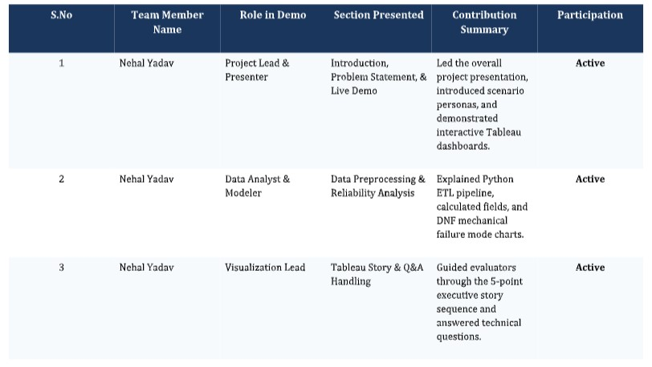

Team Coordination Notes:

